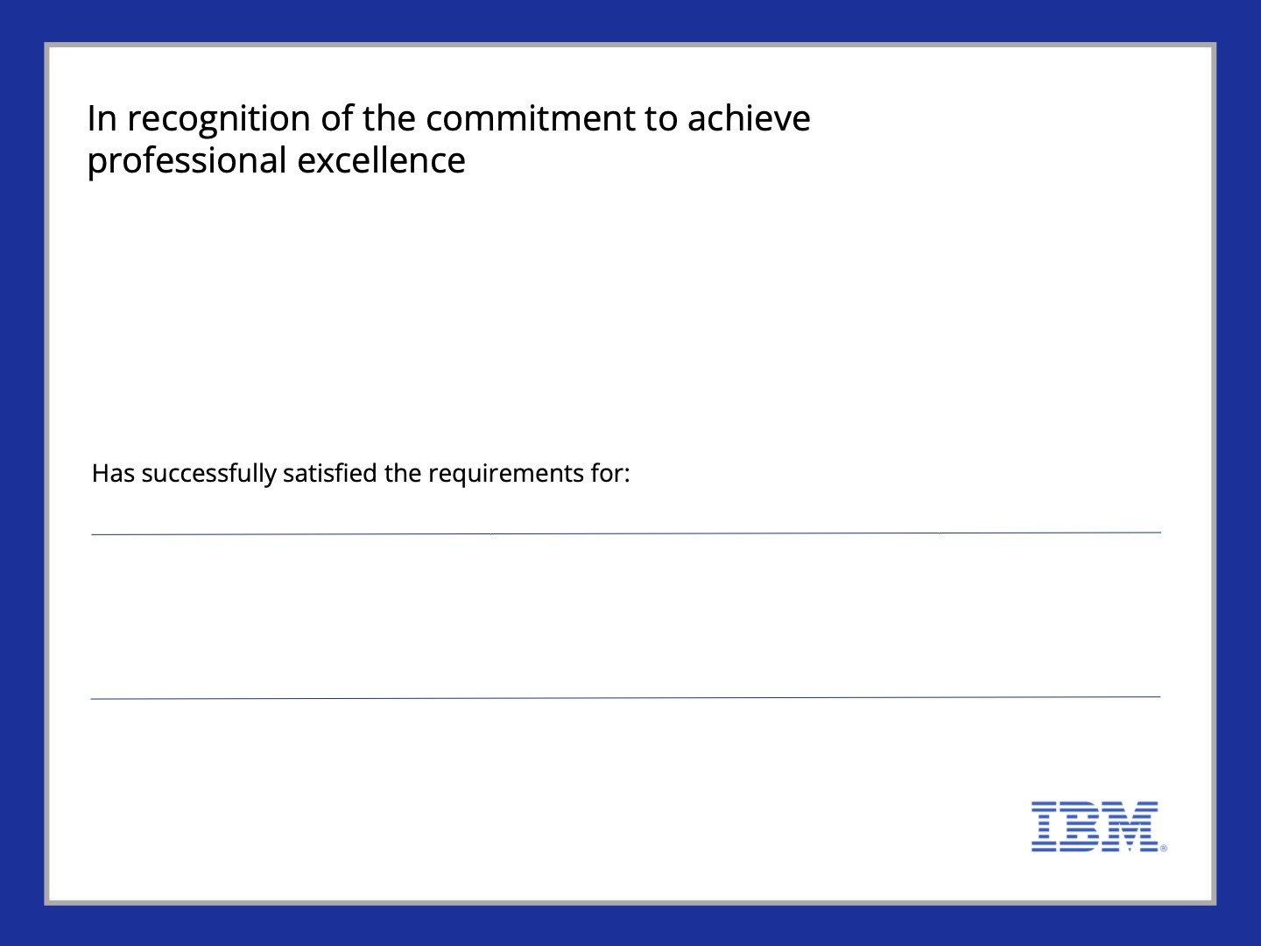

PARANJI DEEPA

Getting Started with Data

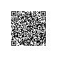

Issued on: Jun 11, 2025

IBM SkillsBuild

Issued by:

Verify:

https://www.credly.com/badges/0ad27cbb-6ec2-46d1-a08d-cf20019cca7b

